Title Of Your One Page Abstract

Chris P. Ewels¹, Nicole Grobert², Gregory van Lier³

¹Affiliation 1
²Affiliation 2
³Affiliation 3
email@presenting.author

NanoteC is one of the longest running series of international nanoscale carbon conferences in Europe (since 1998) [1]. It brings together scientists working with nanoscale carbon materials: nanotubes, graphene, diamond- and fullerene-related nanostructures [2]. While each of these materials attracts its own dedicated community of researchers, NanoteC draws on common themes and allows researchers to share insight into this unique element at the nanoscale [3].
Elemental carbon shows remarkable variety in properties via simple covalent bonding, however, other systems (for example containing nitrogen or metals and low dimensional related layered non-carbon based systems) are becoming important and provide alternative components with unique mechanical and electronic properties. Nanotechnology requires an understanding of these materials on an atomic level and this will be the central theme.

Optional: The importance of different types of Nanostructures is illustrated in Figure 1.

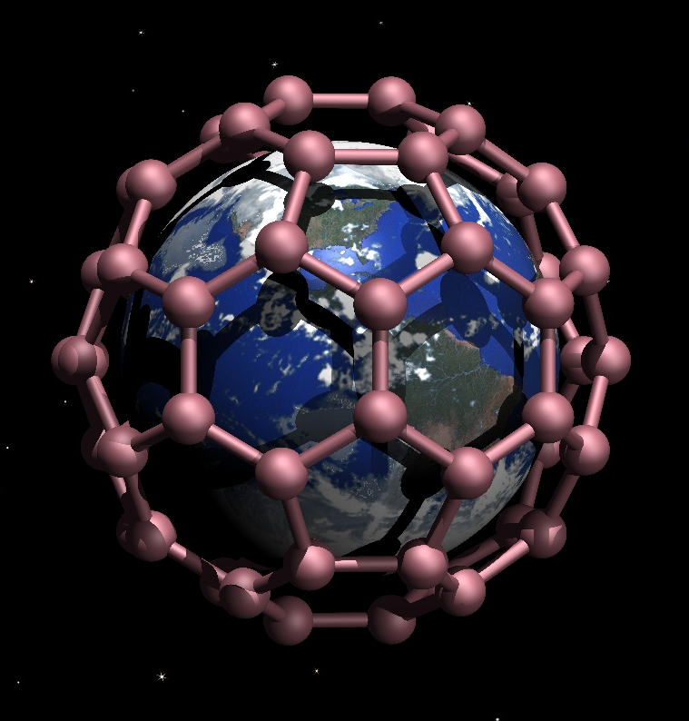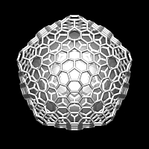
Figure 1. The importance of different forms of carbon nanostructures for NanoteC .

References
1. C.P. Ewels, M. Heggie, H.W. Kroto, Journal, Volume, page (year)
2. N. Grobert, G. v. Lier, C.P. Ewels, Journal, Volume, page (year)
3.

